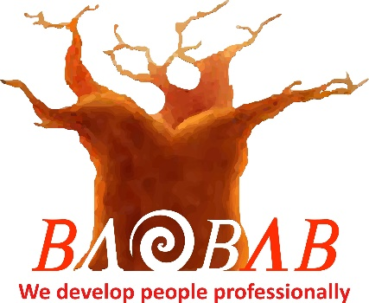

**CONFLICT MANAGEMENT**

**Highfield Level 2 Award in Conflict Management (RQF)**

The objective of this qualification is to prepare learners for employment and support learners who have a customer facing role, dealing with service users or the public.

The qualification provides learners with the knowledge and understanding of how to prevent conflict situations from arising and who would like to gain more confidence in being able to deal with conflict situations.

The qualification is applicable to a variety of work environments and covers topics such as delivery of effective Customer Service and supporting the Customer Service Environment.

**Unit Standards**

**Unit 1 – Managing Conflict in the workplace when dealing with Customers, Service Users or the Public**

* Communication as problem solving tool
* Human responses in conflict situations
* Assessment of risks in conflict situations
* De-escalation of conflict in emotive situations
* Feedback following conflict

**Assessment Methods**

This qualification is assessed through a 1 hour, 30 question multiple-choice question examination. Learners must achieve 66% in order to pass.

**How long will it take me to achieve this qualification?**

The total qualification time for this qualification is 2 days of guided learning, followed by a supervised examination.

**Where can this course be taken?**

Baobab Development Solutions – Cape Town – South Africa

Qualification Number: 600/0670/5 Credit Value: 2